MP2: Simple File System

Joshua Clapp

UIN: 930004089

CSCE410: Operating System

Assigned Tasks

Main: Completed.

Bonus Option 1:

none.

Bonus Option 2:

none.

Bonus Option 3:

none.

Bonus Option 4:

none.

System Design

The system is designed as a doubly linked list that uses an arbitrary assigned hex code of 0xff for the masking of the frames. Then, marking off what frames have been allocated in the doubly linked list should allow for future proofing given the use of previous nodes and tail connections. Tail was not used in this assignment but hopefully will prove useful later.

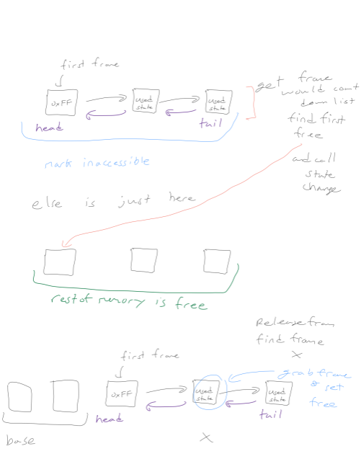

Code Description

I changed cont_frame_pool.C, cont_frame_pool.H, and Kernel.C added logic to find, release frames, set states, and get the state of a frame passed in. To Compile this code, run make, ./copykernel.sh, and bochs -f bochsrc.bxrc and hit enter a few times.

cont_frame_pool.C: set state :

This method was used to decide which bits to flip that indicate a used frame versus a free frame given a frame number using a switch. This logic was mostly given in simple_frame_pool.C.

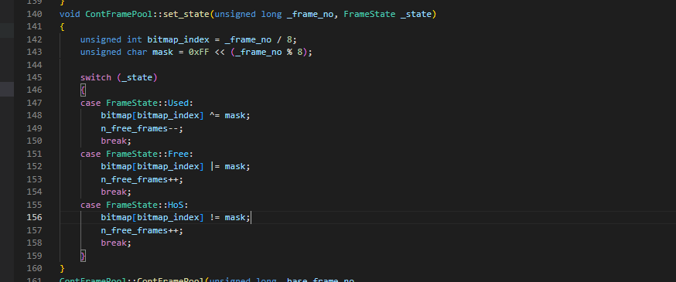

cont_frame_pool.C: get_state :

This method was used to return whether or not the frame is free or allocated. This logic was mostly given in simple_frame_pool.C.

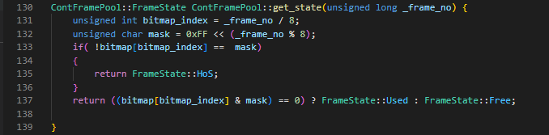

cont_frame_pool.C: allocate memory :

This method was used to allocate memory, set the first head frame to the set, and then apply a double linked list to all future allocated frames. This uses a simple for loop to initialize all parts of the bitmap to be free, and then allocates the head frame as used.

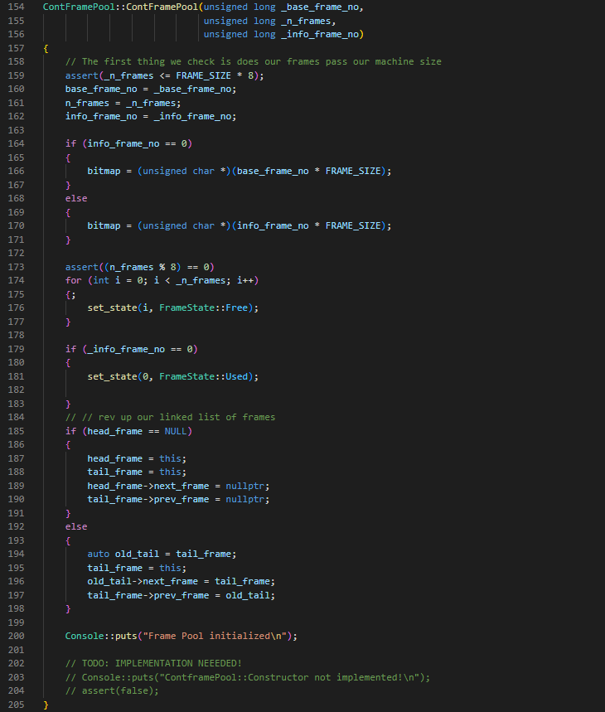

cont_frame_pool.C: get frames :

find an unallocated frame then set the state of the index found returning the distance from the frame found to the base frame.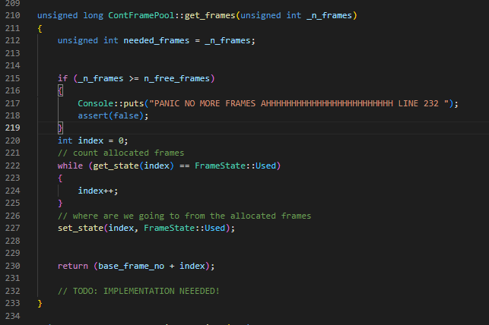

cont_frame_pool.C: mark_inaccessible :

Loop through the base frame to the frames given and set the frame to used.

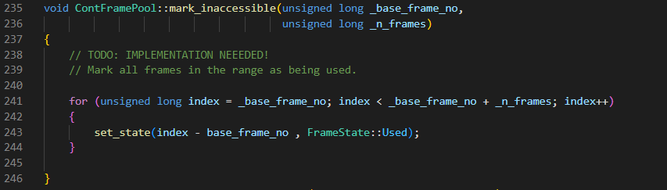

cont_frame_pool.C: release_frames :

This is a combination of function to find the frame position and set it to free

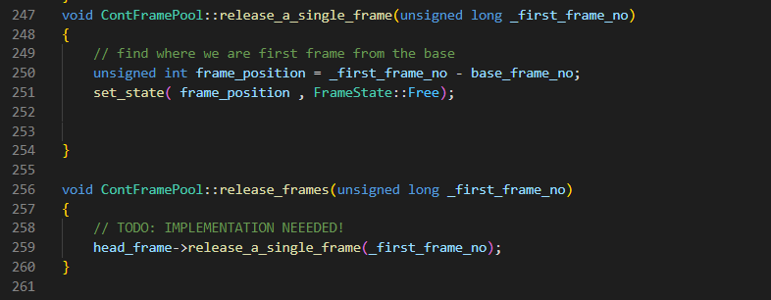

cont_frame_pool.C: needed_info_frames :

Convert the frames to bits and find whether or not we need to add an extra overflow frame. Then find the amount of frames needed for info.

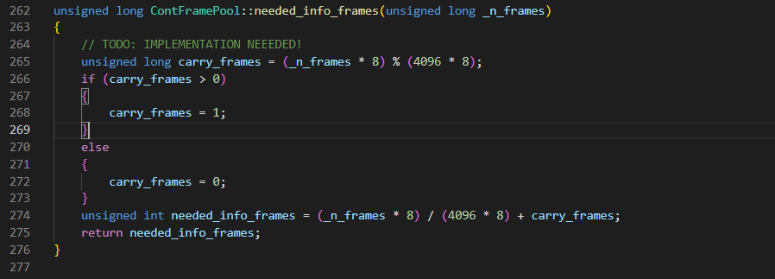

Testing

For testing, I added a few more cases and numbers. This goal is just to cover more bounds. I found that with any number of allocations greater than 62, the frame pool returns an error. My guess is I am leaving the bounds of the assigned given parameters.